Read-A-Thon Week Events:  - Fri. Jan. 11 - Begin to send in books for book swap  - Mon. Jan. 21 - Book Swap*** for middle school  - Tu-Th. Jan. 22-24 - Book Swap*** for elementary  - Fri. Jan. 25 - Dress as your favourite book character - (Book characters sometimes wear PJs)  Cookies and milk - Please send your child with a cup and two cookies. Milk generously supplied by PAC.  Special guests from the community and local authors will be visiting the school throughout the week to help promote literacy and reading.  Literacy-based activities will be happening throughout the week.  - Mon. Jan 28- Fri. Feb 1 - Return sponsor sheets, donations, and reading logs to classroom teacher.  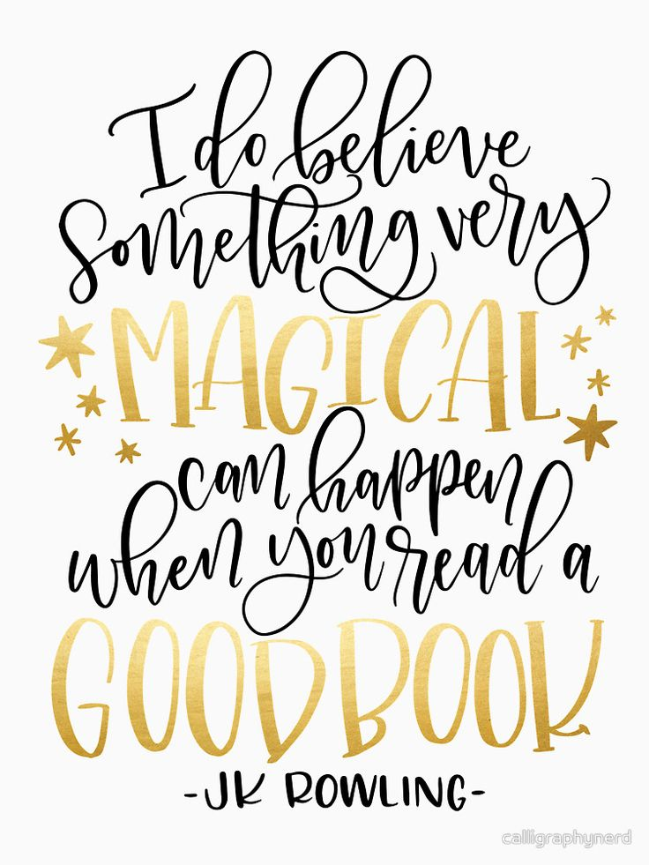  ***Book Swap - We ask families to send gently used books to the school. French or English, fiction or non-fiction. Each student will have the opportunity to visit the library and choose a “previously loved” book to take home.  Please send in gently used books asap.  Thank you for your support in encouraging literacy, reading and building our library. | École John Stubbs  Memorial School  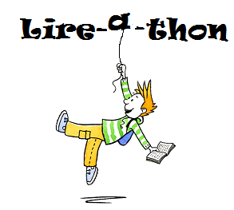  Jan. 18-27, 2019  National Literacy Week  Family Literacy Activities are also being held through  GVPL, Westshore Community and the City of Victoria  Visit: https://southislandliteracy.com  School wide effort for each student to read  20 minutes per day for 10 days  All funds raised will buy French resources for the library

