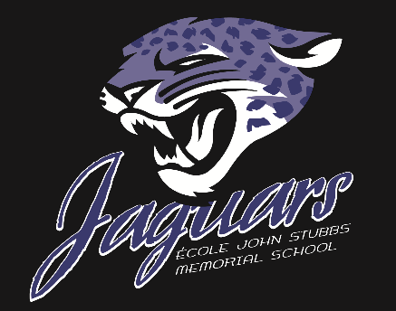
École John Stubbs Memorial School
JAGWIRE
October 10th, 2018

This week….

Wednesday, October 10 – PAC Meeting 6:30pm – Library Learning Commons

Friday, October 12 – PAC Hot Lunch

The weeks to come…..

Thursday, October 18th -

-Great Canadian Shakedown Drill – 10:19am.

-PAC Halloween Dance 5pm-9pm

Thursday, October 18th – Wednesday, October 24 (excluding October 19th)-Scholastic Book Fair – Library Learning Commons.

Friday, October 19th – Professional Development Day – School is not in session.

Tuesday, October 23rd – Victoria Grizzlies visit our school 9:15am-1:15pm.

Thursday, October 25th – Kindergarten pumpkin carving – Elementary Gym from 6pm-7pm.

________________________________________________________________________________

AROUND OUR SCHOOL…..

Please take the time to read the important letter that was sent out earlier in regards to the safety of our anaphylactic students and staff. Thank you.

__________________________________________________________________________________

